CIty of Newark: Silliman Family Aquatic Center
Lifeguard Visual Awareness Training Audit (VAT Audit)
Lifeguard Name: _____________________________ Date: ________________
Auditor Name: _______________________________ Title: ________________
Mark the location of the LIFEGUARD on the diagram with an XX
Mark the location of the VAT on the diagram with an X
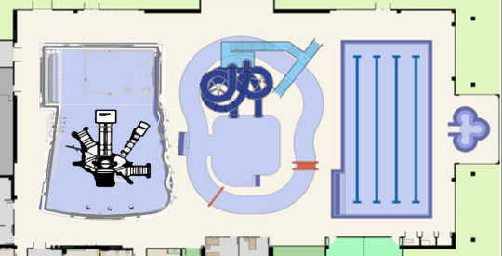VAT Object Used: ❐ shadow doll ❐ brick ❐ guest ❐ other: __________

VAT Placed By: ❐ lifeguard ❐ Senior Lifeguard ❐ other: _______________
Time VAT Placed in the Water: ________ Time VAT Noticed by Lifeguard: ___________
Lifeguard exhibited bottom sweep of zone during rotation? ❐ yes ❐ no
Lifeguard exhibited active scanning of zone during rotation? ❐ yes ❐ no
Lifeguard recognized VAT within 20 seconds? ❐ yes ❐ no, actual time: ______________
Sit time: _____________ Stand Time: ______________ Stroll Time: _____________

Audit Passed? ❐ yes ❐ no
I understand that if I fail a VAT, I can be sent home by the Senior Lifeguard. I understand that I can be released from duty by the Aquatic Coordinator for failing a VAT.

Lifeguard Signature: ________________________ Senior Lifeguard Signature: _________________
CIty of Newark: Silliman Family Aquatic Center
Lifeguard Visual Awareness Training Audit (VAT Audit)
Narrative
DISTRACTIONS:
Staff member distracted by talking: ❐ yes ❐ no
If yes, with who? ❐ staff member ❐ guest ❐ other: ________________________
Fidgeting with the following: ❐ rescue tube ❐ whistle ❐ hands ❐ other
Secondary duties while guarding (ex: cleaning up equipment) ❐ yes ❐ no If yes, what were they doing? _______________________________________________
ROAMING:
​Did the staff member demonstrate proper roaming? ❐ yes ❐ no
Utilize a sit, stand, stroll method every 5 minutes? ❐ yes ❐ no
Demonstrate proper posture? ❐ yes ❐ no
Rescue ready? ❐ yes ❐ no
VISION:
Demonstrated full bottom scan while rotating ❐ yes ❐ no
Demonstrated a fixed scan of the pool or particular zone ❐ yes ❐ no Demonstrated movement that exhibits scanning ❐ yes ❐ no
Scan is systematic or regular ❐ yes ❐ no
Scan is consistent with 10/20 ❐ yes ❐ no
EQUIPMENT/UNIFORM:
Whistle ❐ yes ❐ no
Gloves ❐ yes ❐ no
Fanny Pack ❐ yes ❐ no
CPR Mask ❐ yes ❐ no
CPR Mask inflated? ❐ yes ❐ no
Rescue strap secure with no hanging slack? ❐ yes ❐ no
In proper uniform? ❐ yes ❐ no
ROTATION NOTES:
Did the employee show the proper rotation switch off with arm sweep? ❐ yes ❐ no

